Homework #1
Convert following Decimal numbers to IEEE.

- 5.75
- -11.5
- -0.25
- 0.75

Show your work in the following order:
1. Straight forward translation from decimal to binary number
2. Normalization procedure
3. Formatting into IEEE representation

- 5.75 -> 101.11
- 101.11 * 20
- 10.111 * 21
- 1.0111 * 22
- 101.11 -> 1.0111 * 22
- (-1)0 * 2(10000001 – 1111111) * 1.0111
- 0 10000001 00111 000000000000000000

- -11.5 -> -1011.1
- -1011.1* 20
- -101.11* 21
- -10.111* 22
- -1.0111* 23
- (-1)1 * 2(10000010 – 1111111) * 1.0111
- 1 10000010 00111 000000000000000000

- -0.25 -> -0.01
- -0.01 * 20
- -00.1 * 2-1
- -001 * 2-2
- (-1)1 * 2(01111101 – 1111111) * 1.0
- 1 01111101 00000000000000000000000

- 0.75 -> 0.11
- 0.11 * 20
- 01.1 * 2-1
- (-1)0 * 2(01111110 – 1111111) * 1.1
- 0 01111110 1 0000000000000000000000

-Homework #2 complete the 4:1 Mux Circuit so that it implements the Truth table below>

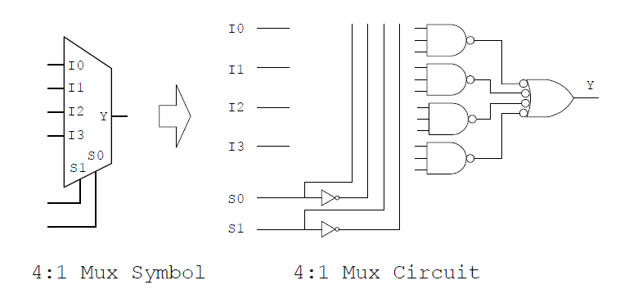

Truth table
s0 | s1 | Y
0 | 0 | I0
0 | 1 | I1
1 | 0 | I2
1 | 1 | I3

